| **Test Name** | | Hide Worker from list in Error Form | | | |
| --- | --- | --- | --- | --- | --- |
| **Use Case Tested:** | | Use Case 9 – Manage Worker | | | |
| **Test Description:** | | A worker is no longer employed by the Pharmacy  User navigates to Search Workers tab  User is presented with a list of all workers  User searches for the ex-worker  User selects the worker from the list  User changes the worker from active (Yes) to non-active (No)  User submits form | | | |
| **Pre-conditions** | | Worker must exist in the system | | | |
| **Post-conditions** | | The database is successfully updated to show the worker is not active  The worker at fault list on the Error Form no longer contains this worker | | | |
| **Notes:** | |  | | | |
| **Result (Pass/Fail/Warning/Incomplete)** | |  | | | |
|  | **TEST STEP** | | **EXPECTED TEST RESULTS** | P | F |
|  | User selects “Search Workers” from the menu bar | | A list of workers appears | X |  |
|  | User searches for ex-worker | | Worker appears in the list | X |  |
|  | User selects the ex-worker | | Worker details appear in the Worker Details form | X |  |
|  | User amends “Is this worker active” from Yes to No | | Input does not show error | X |  |
|  | User selects Submit button | | Message appears that the record was successfully updated | X |  |
|  |  | | Database updated to show worker as not active | X |  |

|  |  |  |  |  |  |
| --- | --- | --- | --- | --- | --- |
| **Test Data Table** | | | | | |
|  | **1** | **2** | **3** | **4** | **5** |
| Test – 1 | 9876 | Harry | Marks | Locum | No |
| Test – |  |  |  |  |  |
| Test – |  |  |  |  |  |
|  |  |  |  |  |  |

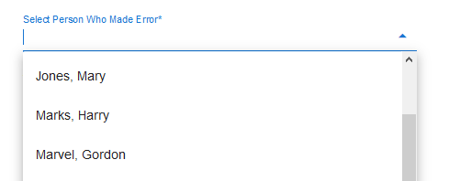

Person appears in the list of workers on the Error Form.

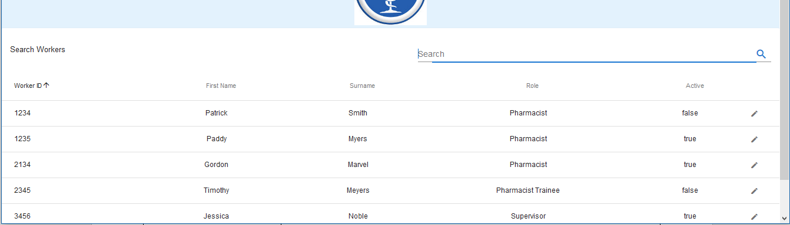

List of current workers appears upon Search Workers tab being selected

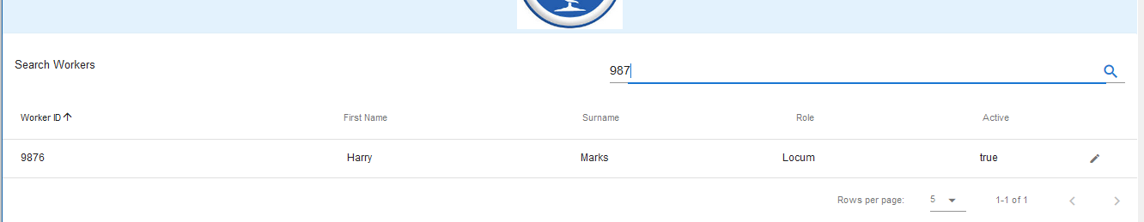

Search for the ex-worker on one of the 5 fields

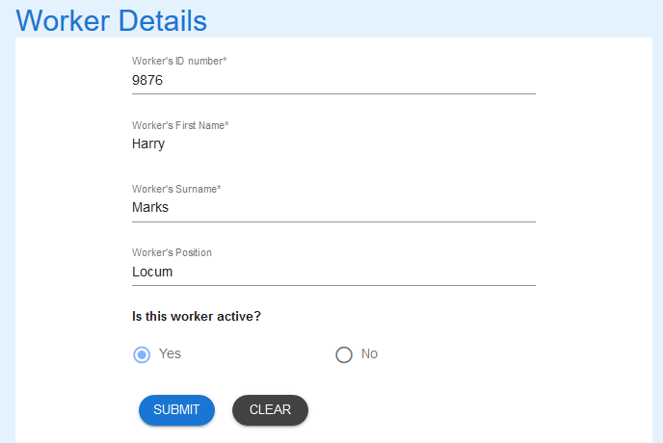

The details for Harry Marks is loaded into the Worker Details form

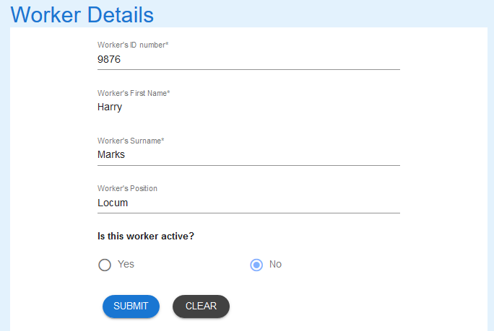

No is selected to change worker to non-active. Submit button is then clicked.

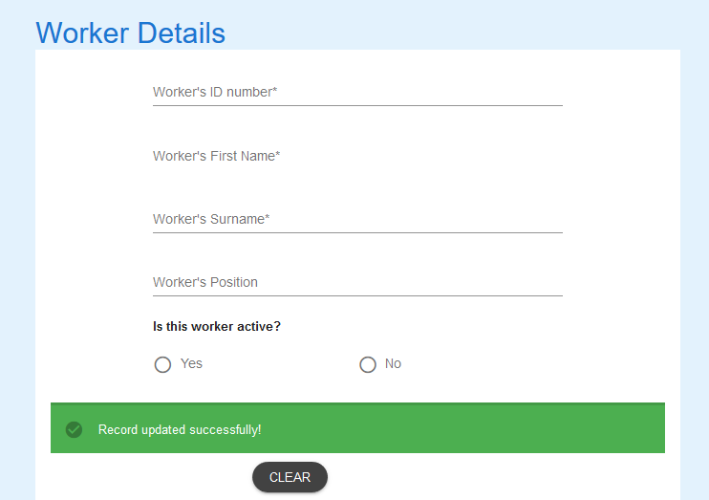

Correct message appears

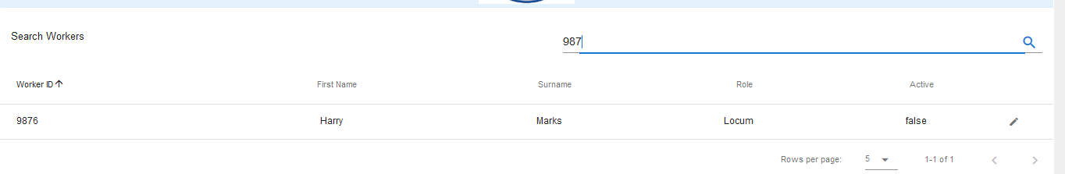

Record updated.

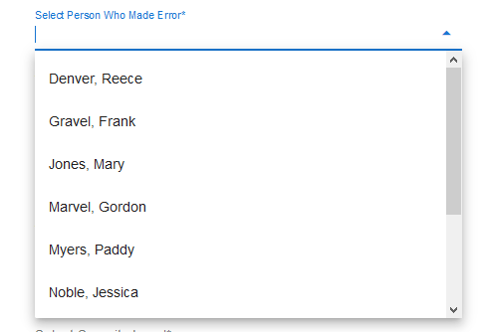

Worker does not appear in the list on the Error Form.